Run-Time Failure Analysis
- Percentage distribution of failure rate over all possible causes:
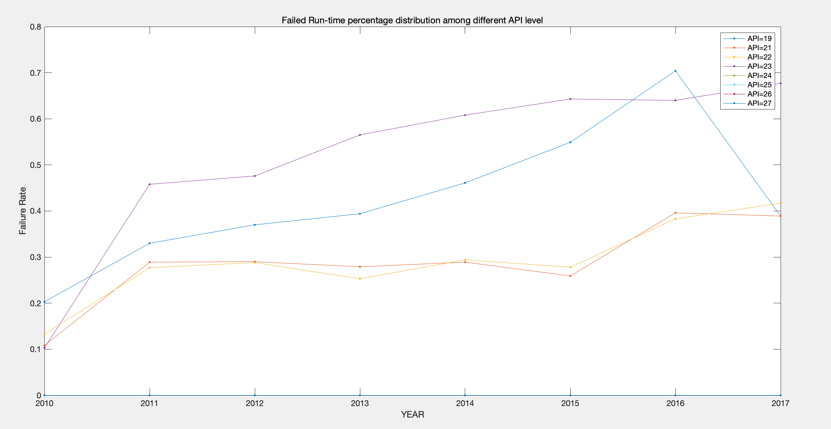

- For aggregate failure rate, concerning (failure rate, SDK release year - app develop year, SDK API level - app minimum API level)
  - Distribution figure (3D)
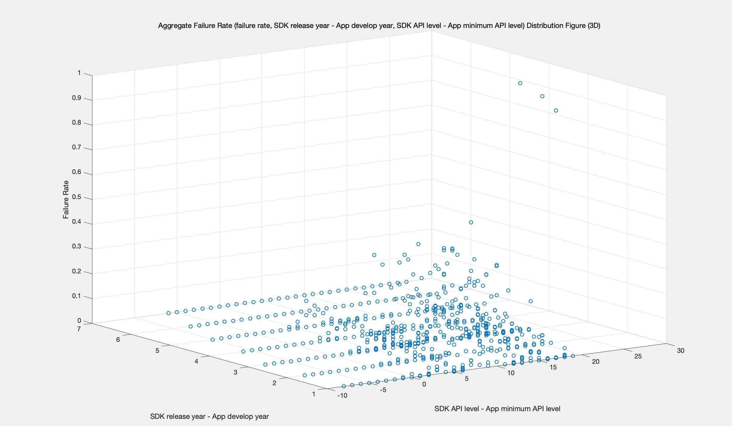
Figure Aggregate Failure Rate (failure rate, SDK release year - App develop year, SDK API level - App minimum API level) Distribution Figure (3D).fig
  - Correlation analysis (non-parametric)
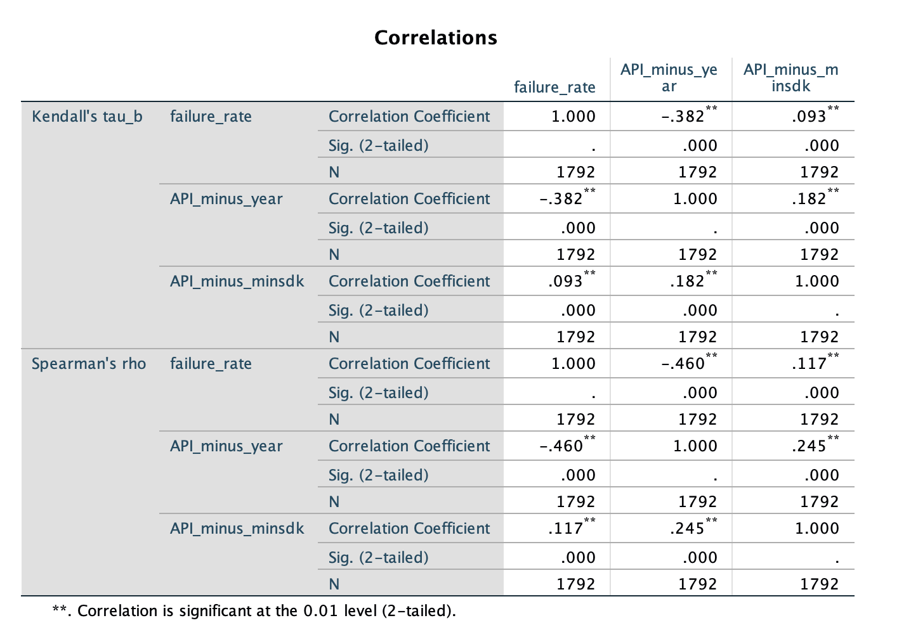
For correlationships:
0.0 - 0.2 very weak
0.2 - 0.4 weak
0.4 - 0.6 moderate
0.6 - 0.8 strong
0.8 - 1.0 very strong

- For major (top)-cause failure rate, concerning (failure rate, SDK release year - app develop year, SDK API level - app minimum API level)
  - Distribution figure (3D)
    - Native Crash – code error at C/C++ layer:
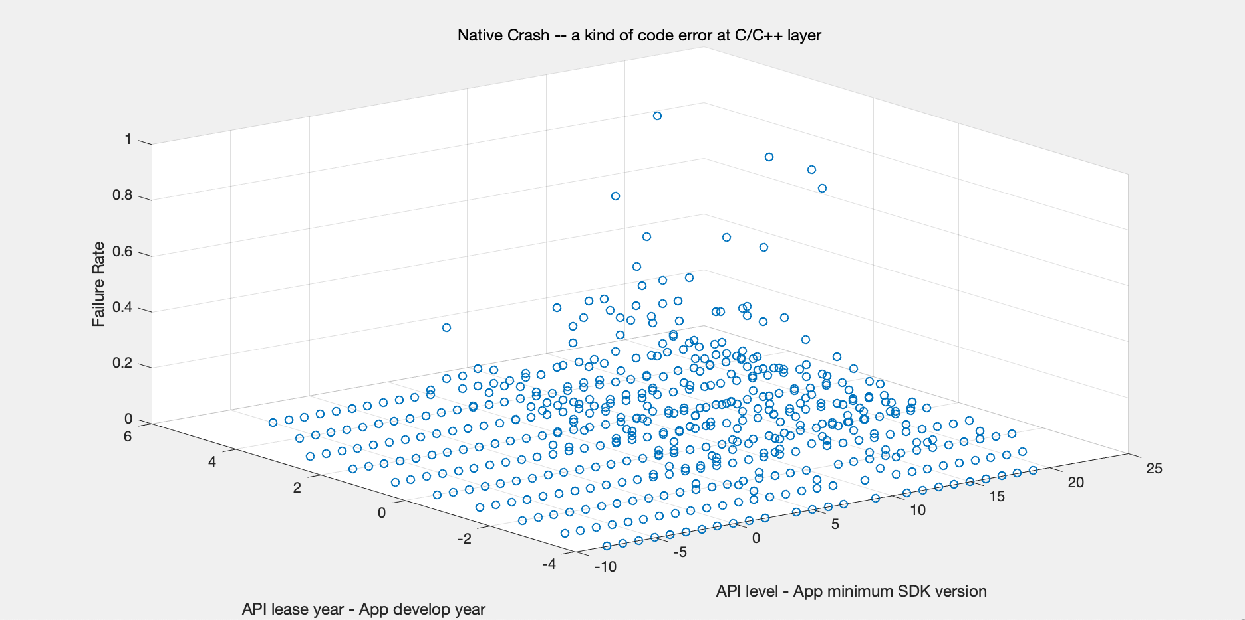
    - Verify Error – incompatibility issues, about API version
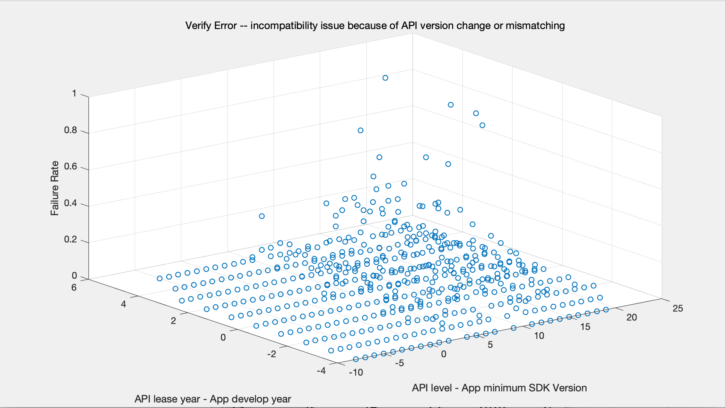
    - Null pointer – Null reference
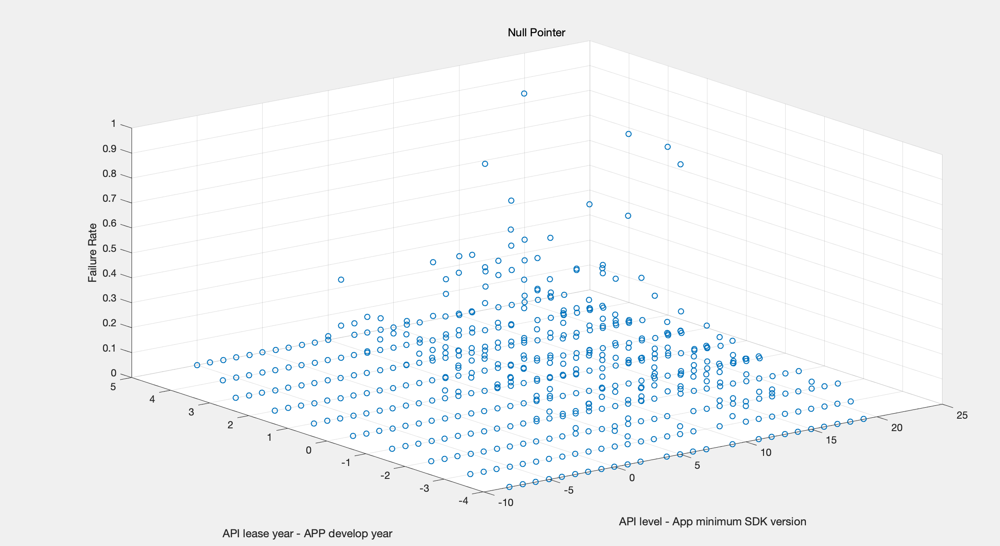

  - Correlation analysis (non-parametric)
    - Native crash
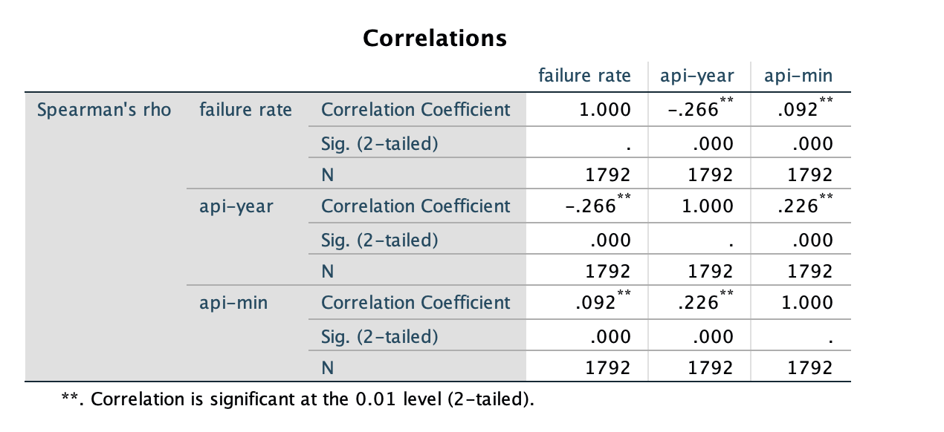
    - Verify error
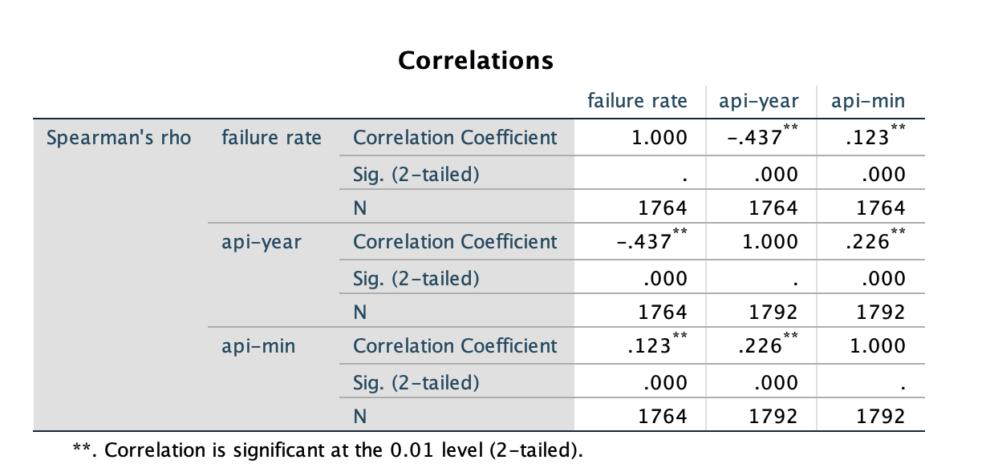
    - Null pointer
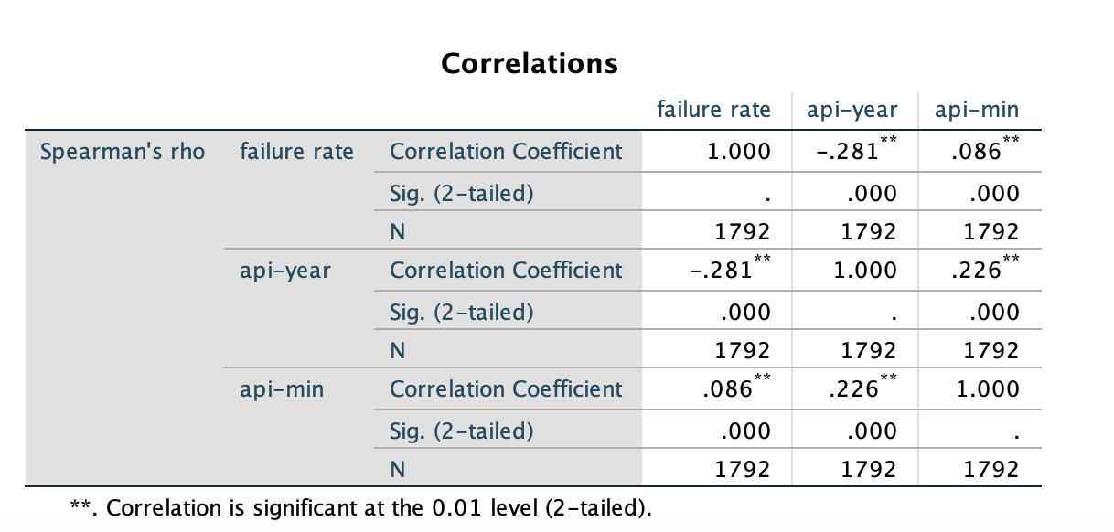
- For aggregate failure rate, concerning (failure rate, SDK API level, app minimum API level, app year)
  - correlation analysis (non-parametric)
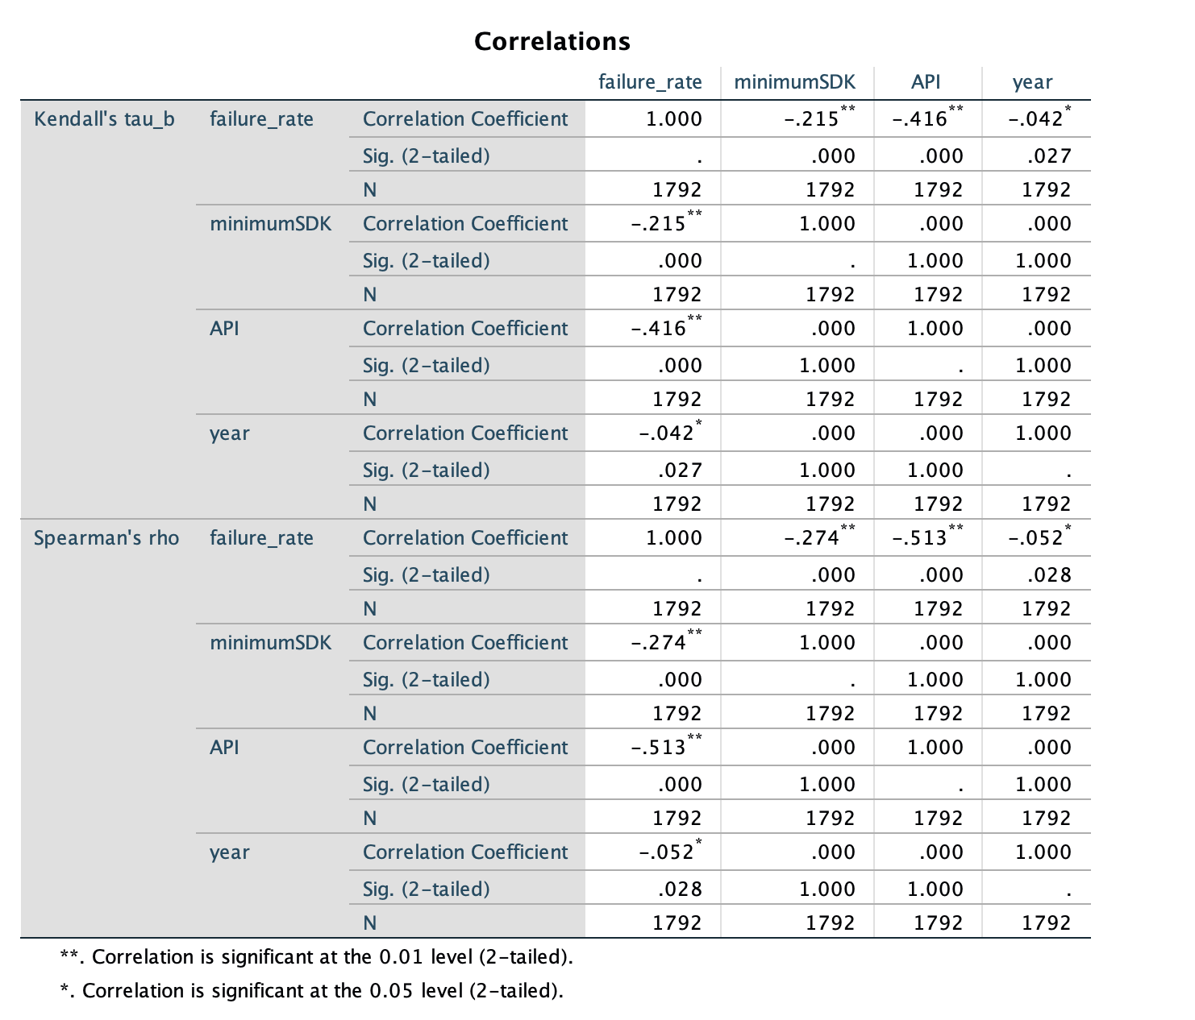
For this part, the correlation between failure rate and API level is higher than 0.4, which is paradoxical with our before the conclusion, I conjecture this is because of the failure rate of the emulator with SDK API level 24,25,26,27 are all zero.

To prove my hypothesis, I calculate the correlation coefficient again without these data, the result is close to our previous analysis.

- For major (top)-cause failure rate, concerning (failure rate, SDK API level, app minimum API level, app year)
  - correlation analysis (non-parametric)
    - Native crash
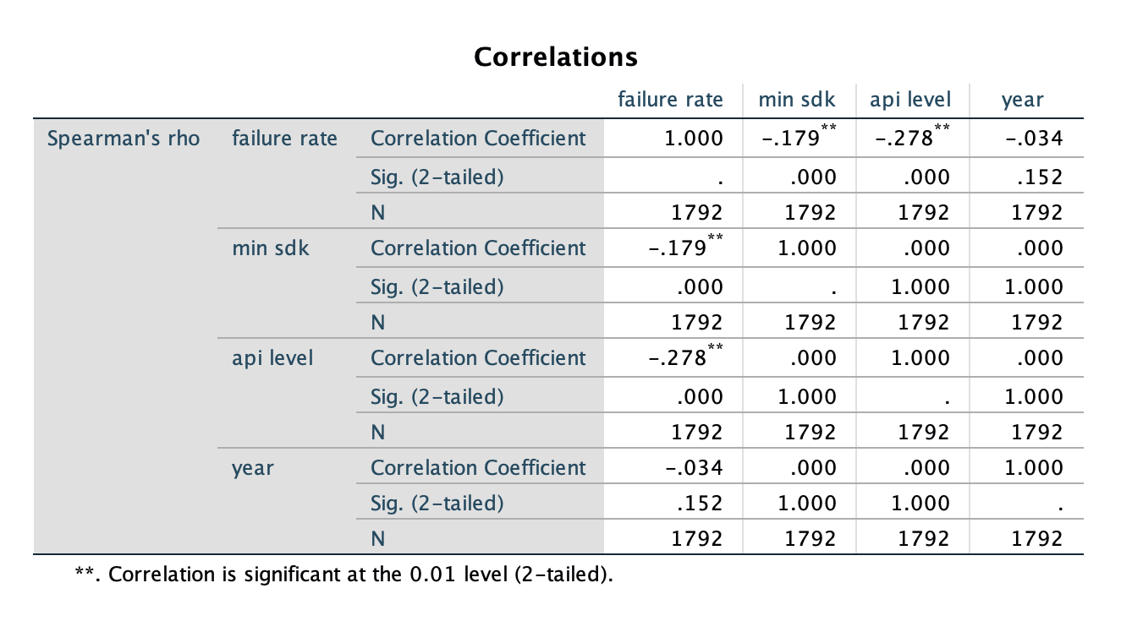
    - Verify Error
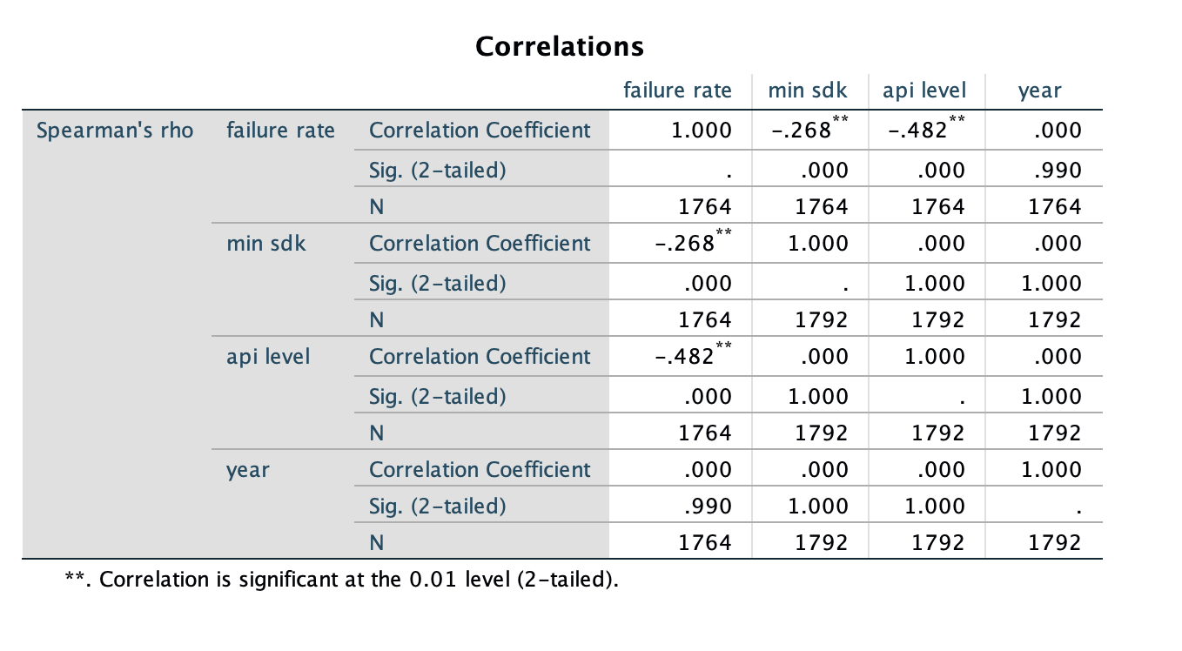
    - Null pointer
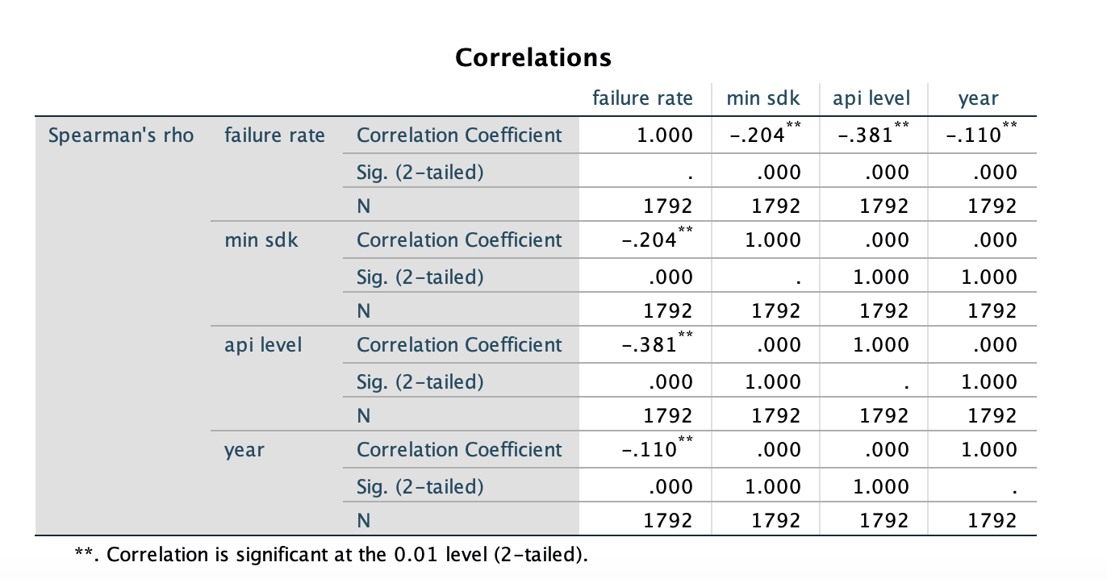
- Percentage distribution of failure causes:
  - all
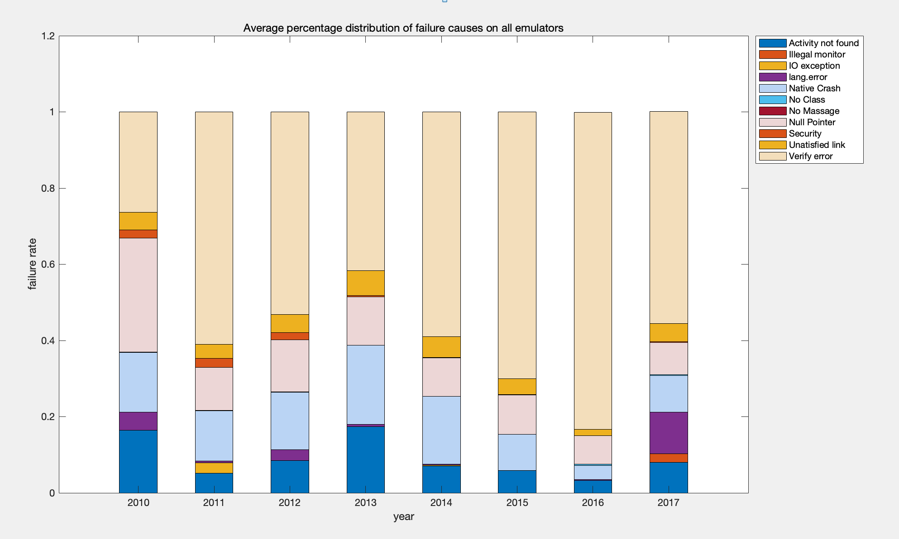
  - 23
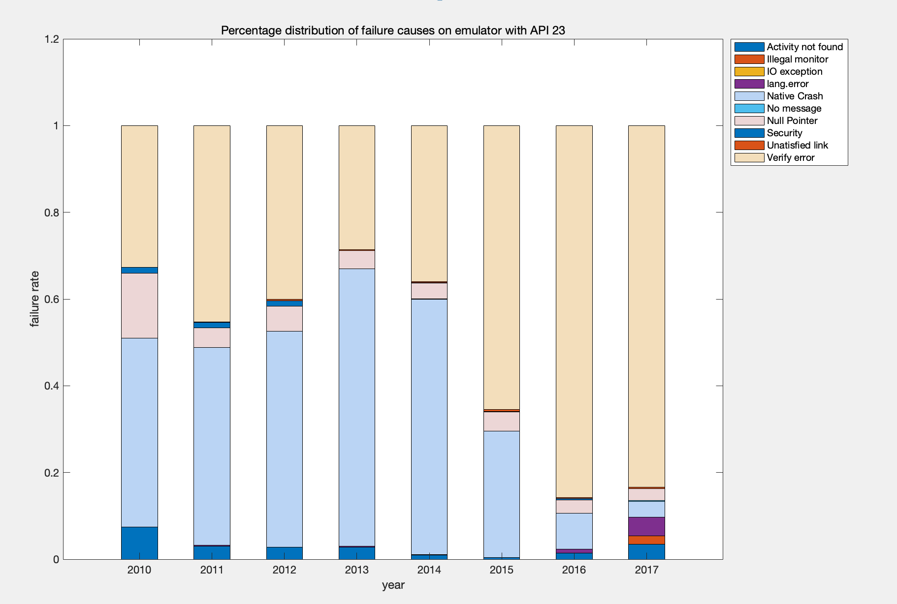
  - 22
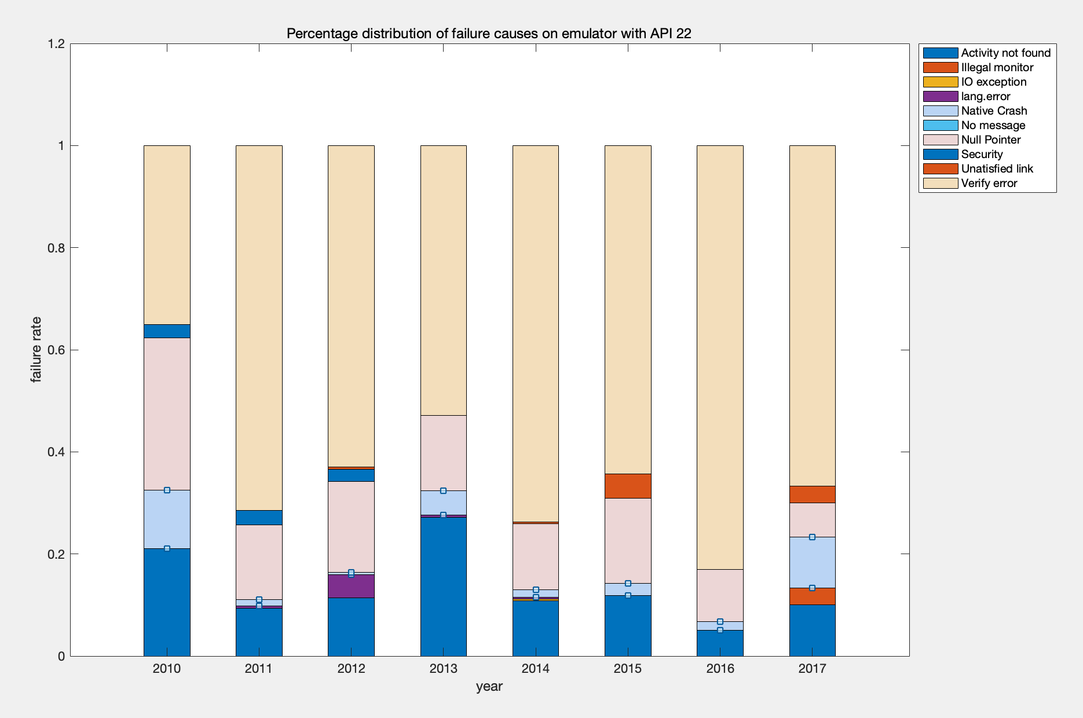
  - 21
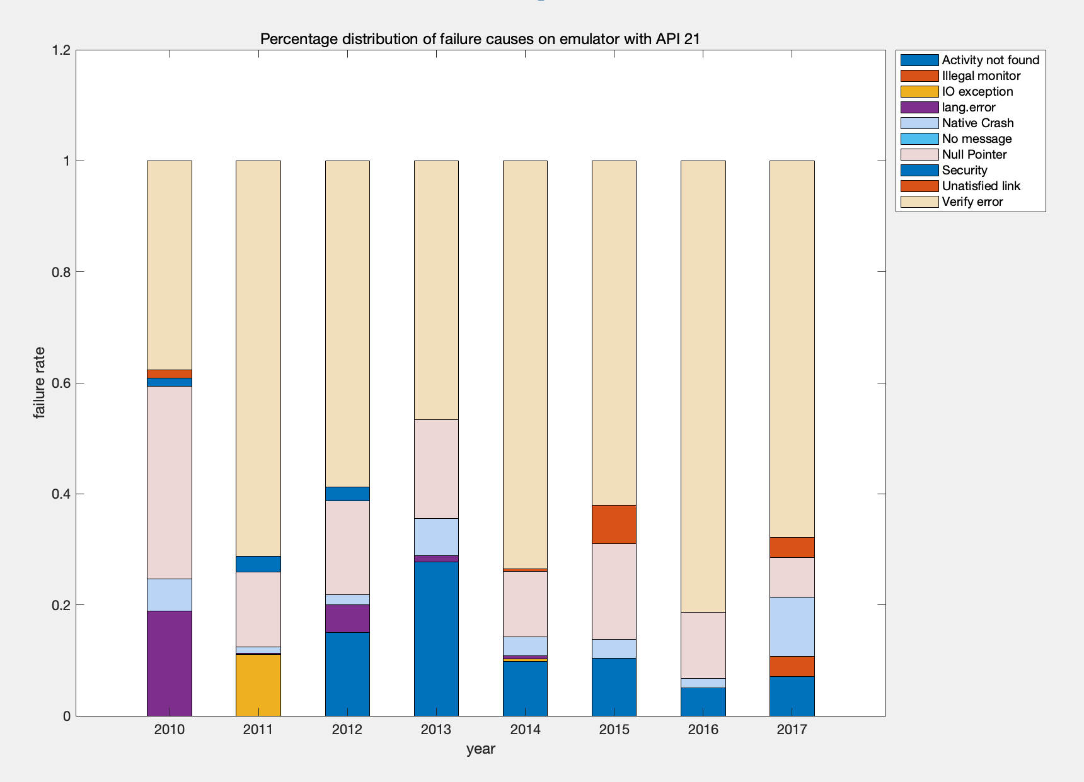
  - 19
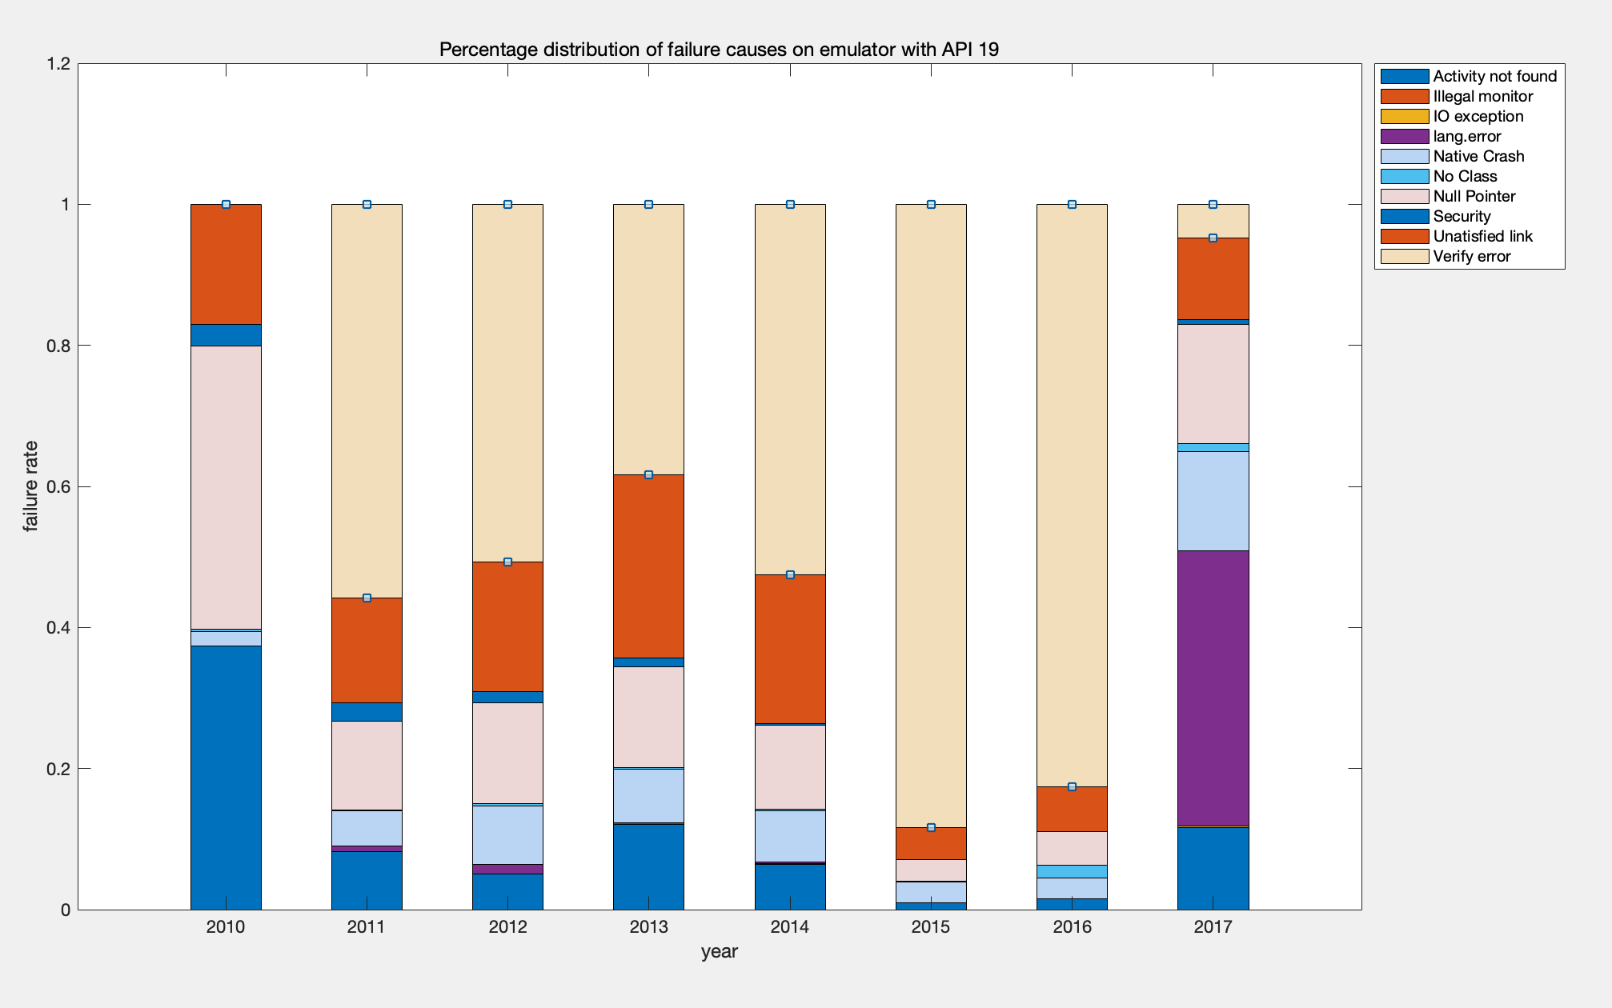
- Notes：
  - For emulator with SDK version 19, several .monkey files are loss, I list their name in the following table:
/home/hcai/testbed/straceLogs/AndroZoo/benign-2010/03850A9F2C0B08C1D418CE792C4C1CB6C8BBABD9414D5649601B006AF7DD8B76.apk
/home/hcai/testbed/straceLogs/AndroZoo/benign-2010/06B933B783DC399116AB6FBCFFD2DECFD2303D98CA973E4666FCAB7CBA5805FA.apk
/home/hcai/testbed/straceLogs/AndroZoo/benign-2010/0099384370322291D8960FCFCD37F71F03DCA1FAA15B2D59B893FA93C87EB274.apk
/home/hcai/testbed/straceLogs/AndroZoo/benign-2010/0346D18C2F58D82686328F55BF7A4CD9C16B9087EADD8C8C9538B80DBF7CE130.apk
/home/hcai/testbed/straceLogs/AndroZoo/benign-2010/06B836E66FC04EF76DB97AAFFFEE51D226D0E0ACFFBD61C3A4C3B75AAB6E22A5.apk
/home/hcai/testbed/straceLogs/AndroZoo/benign-2010/06B79239665FAE77FFBDC5C575EE5FCB41D893662DB80512B69ADB75FDF72986.apk
/home/hcai/testbed/straceLogs/AndroZoo/benign-2010/0914AA8BBF42EDEC0B7F5FAA6EEFBE0AE052DC8BDAD62B48CD67F4457BBD7EE5.apk
/home/hcai/testbed/straceLogs/AndroZoo/benign-2010/09110390A598C39E2B74867B7C4563FF1BCBBDDF714817477D3C331C804248AB.apk
/home/hcai/testbed/straceLogs/AndroZoo/benign-2010/06B37F7F170CF80DE24E5CBBF33B28F6B670596B052F14585DFC641A9278509D.apk

  - For emulator with SDK version higher than 23(that is to say, 24, 25, 26, 27): all APKs run successfully during testing duration (successful rate equals 100%).

  - For emulator with SDK version 19, a new failure cause existing: NoClassDefFoundError, which means the Java Virtual Machine finds the right class at compile time, but not at run time.

Reference for Spearman's rank correlation coefficient:
- https://en.wikipedia.org/wiki/Spearman%27s_rank_correlation_coefficient
- http://www.statstutor.ac.uk/resources/uploaded/spearmans.pdf

